

|  |
| --- |
| Capstone Project Document |

**BOOKAHOLIC SOCIAL NETWORK**

Report #1 – Project Introduction

|  |  |  |
| --- | --- | --- |
| **Bookaholic Social Network** | | |
| **Group Members** | Phạm Thị Huyền | SE03416 |
| Thái Thị Cẩm Vân | SE03409 |
| Vũ Hải Đăng | SE03380 |
| Nguyễn Thị Hải Yến | SE03171 |
| Chu Minh Hải | SE03143 |
| **Supervisor** | Mr. Nguyễn Văn Sang | |
| **Project code** | BSN | |

**- Hanoi, 09/2016 -**

# SIGNATURE PAGE

AUTHOR: Phạm Thị Huyền 12/09/2016

Project manager

REVIEWERS: Thái Thị Cẩm Vân 13/09/2016

Team member

APPROVAL: Nguyễn Văn Sang --/--/--16

Supervisor

Record of change

*A - Added M - Modified D – Deleted

|  |  |  |  |  |  |
| --- | --- | --- | --- | --- | --- |
| Effective Date | Changed Item | A,M,D | Change Description | Reason for Change | Rev. Number |
| 12/Sep/2016 | Create Introduction | A | Create Introduction | First version | 1.0 |
|  |  |  |  |  |  |
|  |  |  |  |  |  |
|  |  |  |  |  |  |
|  |  |  |  |  |  |
|  |  |  |  |  |  |
|  |  |  |  |  |  |
|  |  |  |  |  |  |
|  |  |  |  |  |  |
|  |  |  |  |  |  |
|  |  |  |  |  |  |
|  |  |  |  |  |  |
|  |  |  |  |  |  |
|  |  |  |  |  |  |
|  |  |  |  |  |  |
|  |  |  |  |  |  |
|  |  |  |  |  |  |
|  |  |  |  |  |  |
|  |  |  |  |  |  |
|  |  |  |  |  |  |
|  |  |  |  |  |  |
|  |  |  |  |  |  |
|  |  |  |  |  |  |
|  |  |  |  |  |  |

Table of Contents

SIGNATURE PAGE 2

1 INTRODUCTION 4

1.1 Purpose 4

1.2 Acronyms and Definitions 4

2 ABSTRACT 4

3 LITERATURE REVIEW 4

4 PROPOSAL 6

4.1 The idea 6

4.2 Objectives 6

4.3 Brief description about system 7

4.4 System features 7

4.4.1 Reader/Author features 7

4.4.2 Admin features 9

4.4.3 System features 9

5 BENEFIT FROM PROJECT 10

5.1 For our group 10

5.2 For Community 10

6 CRITICAL ASSUMPTION AND CONSTRAINTS 10

7 POTENTIAL RISKS 11

8 REFERENCES 11

# INTRODUCTION

## Purpose

This document is created as the introduction for project Bookaholic Social Network – our Capstone Project at FPT University. In this document, we will descript the overview of some existing systems, the initial idea for our project, a brief description about our expected system and some potential risks, critical assumptions, constrains. Moreover, this document also shows opportunities what it offers for users.

## Acronyms and Definitions

|  |  |  |
| --- | --- | --- |
| Acronym & Abbreviation | Definition | Note |
| BSN | Bookaholic Social Network |  |
| FU | FPT University |  |
|  |  |  |
|  |  |  |
|  |  |  |
|  |  |  |
|  |  |  |

**Table 1-1:** Definitions and Acronyms

# ABSTRACT

Nowadays, social network plays an essential role in our lives. Vietnam is the country that has the big Internet user growth and the trend of communication through social network is expanding rapidly, people shares and discuses about everything through social network. However, there is not any social network that is for only Vietnamese people who love reading books. To solve this problem, we create a website where people who loves book can share and discus with others about their favorite books or authors. We believe this project will strengthen Vietnam’s reading culture.

# LITERATURE REVIEW

There are some social networks about book. For example: Goodreads, Shelrafi, Wattpad, etc. However, there is not any social network about books for Vietnamese only.

* **Goodreads**

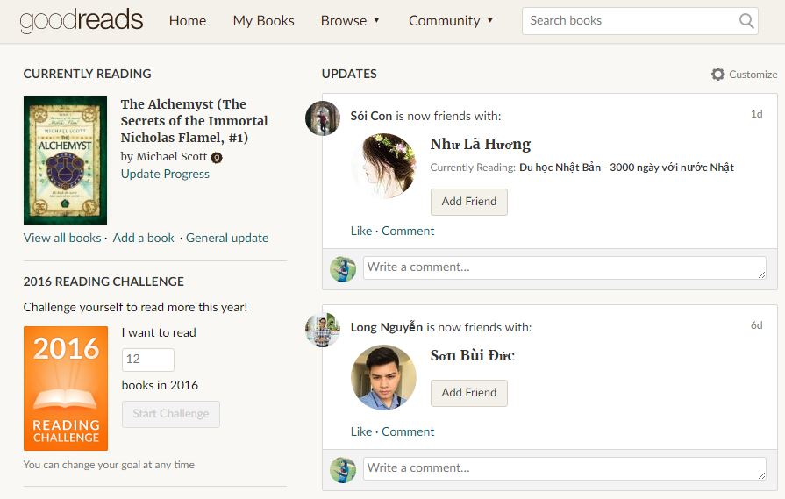

Figure 1-1: Website Goodreads

Goodreads is a platform that allows members to recommend books, create connection with other members or follow a club to keep track of what they’ve read and would like to read.

* **Advantages:**

- is the largest and most popular site about books.

- has well-design.

- has huge and detail database about books and authors.

* **Disadvantages:**

- has no real filter between kid and adult content.

* **Wattpad**



Figure 1-2: Website Wattpad

Wattpad is a platform that authors and publishers use for online engagement and to create purposeful relationships with readers.

* **Advantages:**

- is friendly with users.

- allow members to free create their own story (free)

* **Disadvantages:**

- has no real filter between kid and adult content.

- has no real actions to validate content of stories and report about copyright problem.

# PROPOSAL

## The idea

Nowadays, as the negative side of social media, teens are not often reading books, especially traditional books. In Vietnam, almost people prefer to spend time for web surfing than read a paper books. Our idea is creating a website that allows people to share and talk about books they would like to read or authors they are interested in. This project aims to make more fun in reading to encourage people especially teens to read more.

## Objectives

This project is the Capstone Project in FPT University studying program. Firstly, this project is responsibility for all team members. Therefore, we must complete all requirements from teacher and FU. During the time doing project, we can learn how to develop a project, how to manage project, how to communicate better between team members, how to control time and how to perform teamwork effectively. Moreover, we will also have experience in .NET technology, website designing and software testing. Therefore, we think this project is very necessary for us to improve skills, knowledge which we studied in FU. Moreover, this project also makes our CV more attractive after graduating from FU. This is also an opportunity for us to prove capacity with recruiters.

Secondly, we all know that it is worth reading books. We believe this project will strengthen Vietnam’s reading culture. Specially, our website displays completely in Vietnamese, so users can use functions easily, even though they do not know English.

## Brief description about system

This software is a platform for social reading with friendly and attractive interface to make people more interested in reading. Members can share and discus about books. They can also send request to admin to add new books or report about copyright problem.

BSN uses familiar technologies as: Bootstraps, .NET MVC5, etc. We are planning to develop a mobile version for easily connecting.

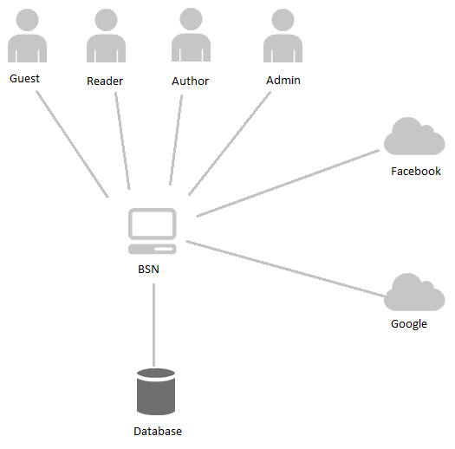

Figure 3: Brief descriptions diagram of DDL system

## System features

About the features of BSN, we focus to provide for users main features as searching, recommend, discus about books, etc. Admin can manage members, database and manage the development of website through our statistic.

The detailed features are below.

### Reader/Author features

* Manage account:
* Register: Users can register an account. However, there are difference between reader account and author account. If users want to have an author account, they will have to wait admin to validate their personal information first.
* Login/Logout: Users login/logout an account to use or exit system BSN. They can login by registered account, Facebook account or Google account.
* Edit profile: User can edit their profile such as name, date of birth, etc.
* Reset password: If users forget their password, they can send request and system will send them an auto mail to confirm new password.
* Manage recommendation:
* Post a recommendation: User can recommend about a book or author as a post. To recommend a book or author, users are forced to tag that book/author.
* Edit post: Users can edit both caption and tag of post.
* Delete/Like/Share a post.
* Comment/Reply a comment on a post: Users can comment on a post and also can reply others comment on a post.
* Delete/Like a comment/reply-comment.
* Manage interactions:
* Follow other accounts.
* Report other accounts/groups: Users can report other accounts/groups if those accounts/groups have invalid content or copyright infringement.
* Send message to other accounts.
* Send join-group request: There are several groups about books or authors and users can request to admin of a group to be its members.
* Out a group: If users see a group is not appropriate with them or they do not want to join a group anymore, they can remove themselves from that group.
* Manage groups:
* Create a group: To create a group, users have to tag a book or author as the topic of that group.
* Add new member to a group: Admin can add new members to their group by entering their name or accept join-group request.
* Manage group members:
* Set other members admin: Only admins can set other member admin.
* Remove members: Admin can remove members out of their group
* Edit group profile: Admin can edit group information as name, cover photo, etc.
* Delete a group: Admins can delete a group. To delete a group, they have to remove all of its members.
* Manage group post:
* Create a post in group: All members can create posts in a group and they do not need to tag a book/author.
* Edit a post in group: The owner of a post can edit their post.
* Delete a post: The owner of a post can delete if they want. Admins can also delete a post if they see it is inappropriate.
* Search: User can search for books, authors or other accounts
* Rate a book/publisher

### Admin features

* Manage user account:
* Search user: System admin can search for users and view their profile, posts, etc.
* Ban/Unban users: Admins can de-active user accounts.
* Delete user accounts: Admin can delete user accounts in case it is not in use.
* Decline requests about reporting an account/group: If a report is not valid, admin can decline it instead of approving.
* Accept/decline request about creating author account: Admins can approve or decline request about creating author account if it is valid or not.
* Manage slides:
* Add new slides: Slides are pictures showed off to help guests preview about our website. Admins will add new slides if need.
* Delete slides
* Active/De-active slides: If a slide is not in use, but admins want to keep it for using in future, they can de-active it and active when they need.
* Manage publishers:
* Add/Update/Delete publishers
* View statistic:
* View statistic about number of users/authors/group
* View statistic about access times

### System features

* Send confirm mail to active an account: When a guest register an account, system will send an email to confirm.
* Send mail to reset password: When a guest send request to reset password, system will send an email to confirm.
* Send warning mail to reported user: If a user is reported by other account, system will send warning email to him/her.
* Static:
* Statistic number of readers/authors/group
* Statistic access times
* Suggest book/author: Through users’ vote about books and their following authors, system will calculate and suggest books or authors they may also like.

# BENEFIT FROM PROJECT

## For our group

After developing and implementing this project, our group will get some benefits:

* Have more experiences of software project management how to manage plan, time, member and risk.
* Have more knowledge and skill about .NET MVC5, Bootstrap and other skills about real-time programming.
* Know how to communicate with team members and how to teamwork more effective.

## For Community

Just need to have a device that can connect to the internet and any web browser, user can:

* Easily join a community about books.
* Share and discus with others about their favorite books or authors.
* Update information about new books and trend of reading quickly.
* Find friends who have the same reading hobbit like them

# CRITICAL ASSUMPTION AND CONSTRAINTS

* Critical assumption:
* Training: Almost members just have basic knowledge about C# asp.Net. We do not have experience in C# asp.Net MVC5, html, CSS, etc.
* Human resources: Assume that all members in team have a good healthy to do their tasks.
* Constraints:
* Time and deadline: We must complete task on time. Our project runs for 14 weeks. Each member works 5 hours/day and 5 days/week. We do not have much time to complete developing and deliver application. Besides, we have to submit report documents before deadline to review.
* Quality: The products must be run well when users perform main functions in Google Chrome 4.0 and Firefox 3.0 or higher.
* Process: We have to follow the Iterative and Incremental process.
* Human resources: Our team has 5 members, each member have to study 2 subjects (JPS and JIT) at school.

# POTENTIAL RISKS

After studying about this project, we find out some problem that we may be encountered:

* Under-estimate scope and time or miss deadline because lack of experience in group working, managing and controlling work.
* Loss data, source code before uploading data to server because of careless.
* Human resources: Team member cannot complete their works because of health reasons, key member leave team or un-cooperating on team.
* Change requirements: Requirement changed when some functions cannot be completed or some technologies are not suitable.

# REFERENCES

* Goodread at URL: <https://www.goodreads.com>
* Wattpad at URL: <https://www.wattpad.com>